**CT331 Assignment 2**

**Functional​ ​Programming​ ​with​ ​Scheme**

**Chika Onyia**

**15736825**

*Question 1*

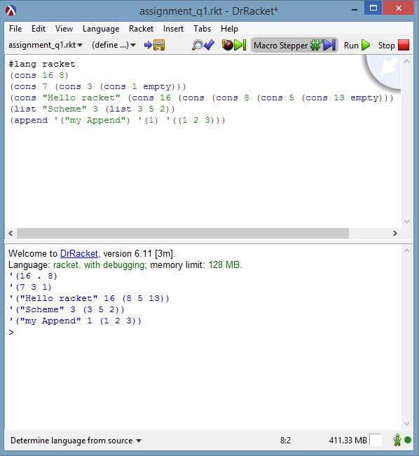*Screenshot*

*Question 1* Comments

Cons function allows you to combine two notations, example “x” “y” or simply S-expression into a single pair.

List on the other hand is implemented on top of cons can take any number of cons pairs and combine them into one list.

While the Append function like List can take multiple cons values, but or a List values simply copy the list into new block.

*Question 2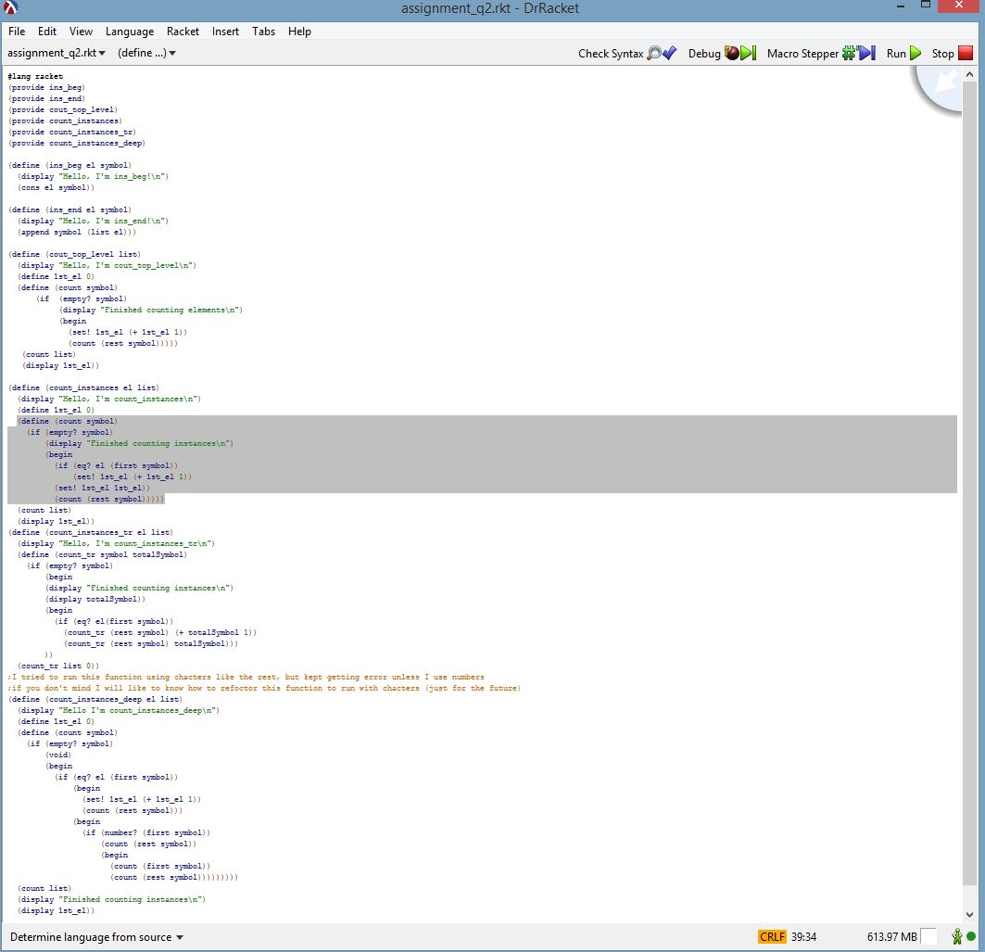*

*Question 3*

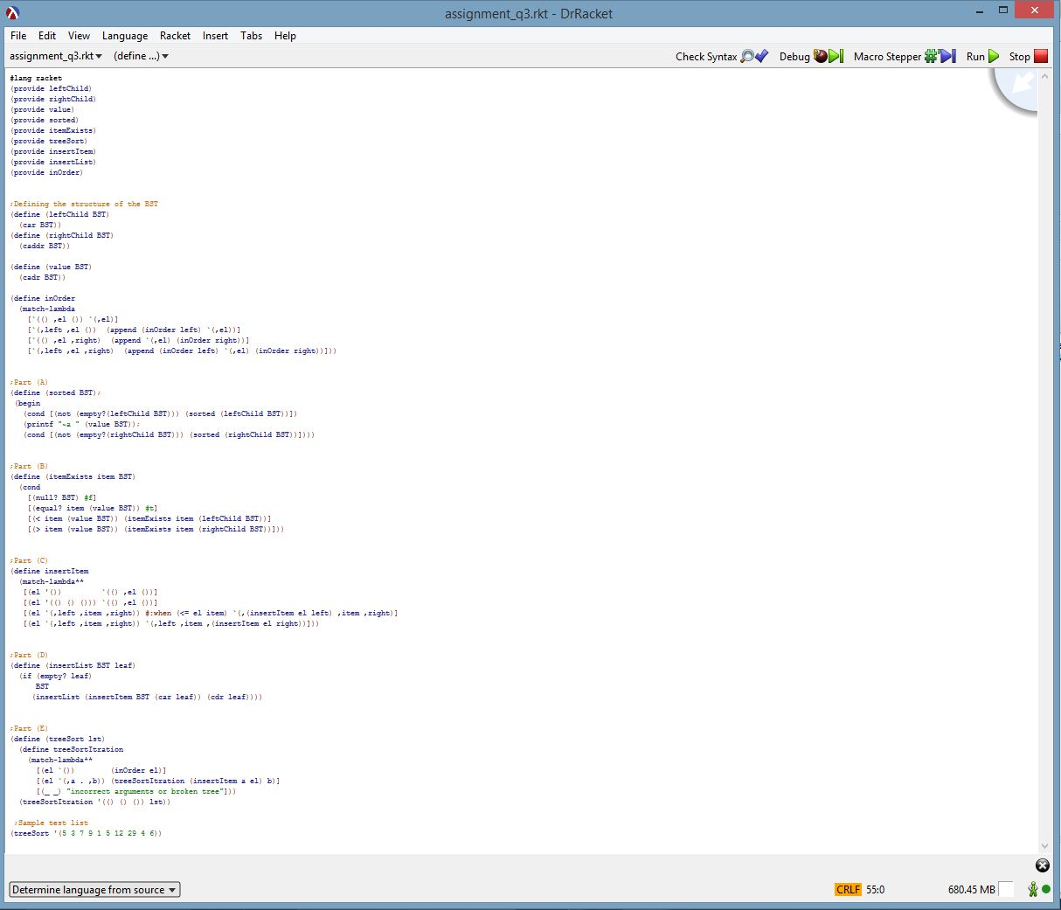

*Test*

